Circle Language Spec: Objects

Objects Main Concepts

Objects
The most basic element of a computer program is an object. An object represents thing, an idea or a place, a number or a collection of other things or anything else. All those things are called objects.

An object in a diagram is represented by a circle, drawn with a solid line:

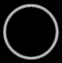

Sub-Objects
One thing can be composed of other things. In that case it can be said that one object contains a number of sub-objects.

When one object contains sub-object, the sub-objects are placed right inside another object.

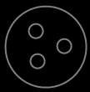

Object Reference
An object can contain sub-objects, as explained in the article Sub-Objects. A sub-object can also point to another object, that actually resides elsewhere in the system, so that an existing object can function as another object’s sub-object. In that case the sub-object is an object reference, that redirects to another object.

An object reference is also called a pointer.

When a sub-object is actually an object reference, pointing to an object elsewhere in the system, then the symbol representing the sub-object will get a line, that is connected to the symbol representing the actual object, which usually resides outside the parent object.

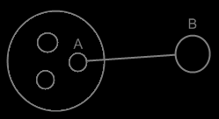

The sub-object A is an object reference to object B. Object references usually point outwards, out of an object.

Related Objects
Because sub-objects can also be references to object that reside totally elsewhere in the system, they are also commonly called an object’s related objects.

Related objects are sub-objects or object references inside another object. Related objects are another name for sub-objects and sub-object-references.

All the circles inside the bigger object are the bigger object’s related objects.

Nothing
When object A has a related object B, sometimes nothing is filled in yet as the related object. In that case it is said that B is Nothing or Null.

When a related object is nothing, a cross is filled in inside the shape:



Other shapes introduced later can also be marked out with a cross, to indicate nothing is filled in.

